Ideation Phase
Define the Problem Statements

Date | 30 September 2026
Team ID | SWTID-2026-8455
Project Name | AI - FAQ ASSISTANT
Maximum Marks | 2 Marks

Customer Problem Statement :
A Customer Problem Statement helps you clearly understand the challenges, needs, and expectations of your customers from their point of view. It guides you and your team to identify the real problem instead of focusing only on the solution. By understanding what customers experience, what they need, and what difficulties they face, you can develop products or services that better meet their expectations. It also builds empathy and provides a clear direction for creating effective, customer-focused solutions.

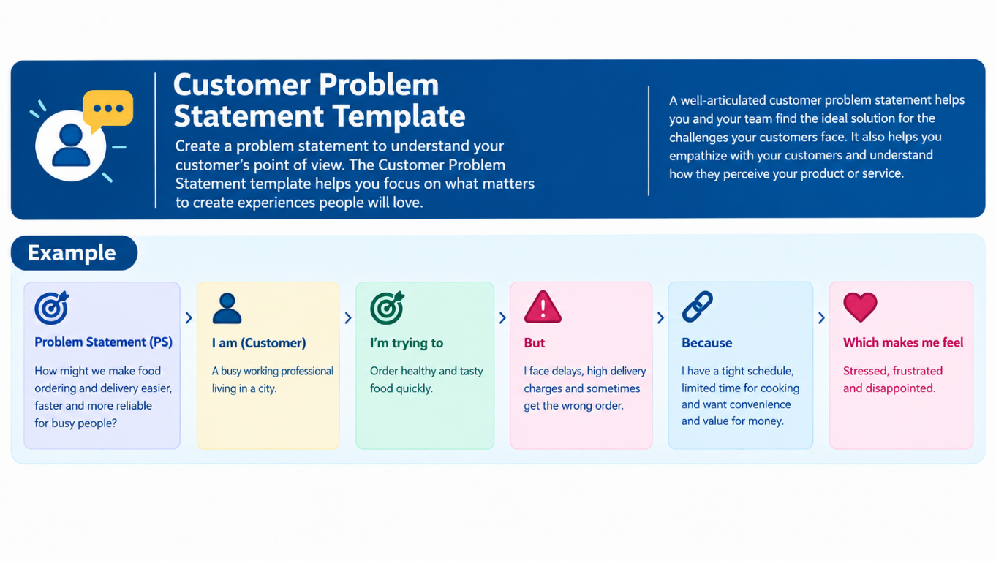

Example:
Problem Statement (PS) | I am (Customer) | I’m trying to | But | Because | Which makes me feel
PS-1 | A customer | Get quick answers to common questions | I have to wait for support | Information is difficult to find quickly | Frustrated and impatient
PS-2 | A customer | Find accurate information about a product/service | FAQ information may be unclear or scattered | There is no instant personalized assistance | Confused and uncertain

